**18756 Project 7 – GMPLS**

**Overview**

In this project you are going to implement a GMPLS network with two layers: packet and wavelength switching. There are two main parts. First, you are requested to implement the LSP setup using an overlay model. Second, you will be requested to create a few scenarios where the LSP setup may fail. In the last part you are required to implement a simple failure localization mechanism in order to identify the link where the failure occurred.

During the project you will work with GMPLS routers that differ in their switching capabilities: PSC (Packet Switching Capable) and/or LSC (Lambda Switching Capable). To setup the different routers you only need to add either IP or optical links between them (see example.java). All links use the same class (OtoOLink), but you can specify if they are optical or not by using the appropriate constructor.

To perform signaling you will need to define how to implement the control channels. Whenever you connect two PSC capable routers the control channel can be implemented inline, i.e. using the same link you will use for data packets. However, when you connect two LSC capable routers you will need an out-­‐ of-­‐band control channel. To simplify, you can create an explicit IP link between any two LSC routers to implement the control channel (see example.java). All signaling packets should be sent through the control channel. This link should be created whenever you create an OtoOLink. Remember, all signaling should be sent through this control channel.

You should write a report describing your implementation and presenting your results (namely, the output of your programs). Be **concise**. Apart from the outputs of your program, we expect no more than a **4-page report**.

You should follow the guidelines provided in the following sections, but you are free to add enhancements that you might find interesting. Make sure you mention them in your report so that they can be considered when grading.

**Part I** [50% implementation + 12% report]

1. Create the following network (i.e. create routers and setup the links between them):

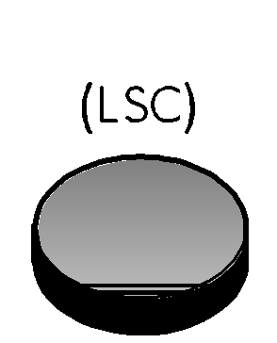





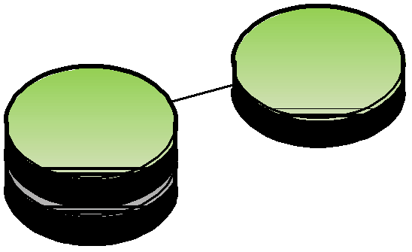

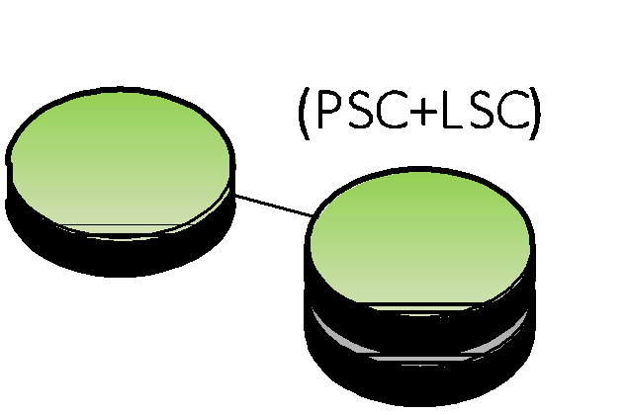

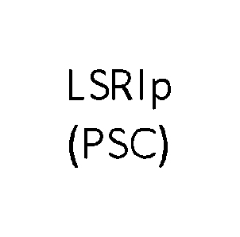

Once this simple network is in place, you should setup the LSP path. You **must** implement the following messages. As you might remember, you had to implement these messages in the previous project, so you can re‐use any of **your** previous code.

|  |  |
| --- | --- |
| Message | Explanation |
| Path | Establishes path from source to destination |
| Resv | Reserves resources along the path |
| ResvConf | Confirms resource reservation |
| PathErr | Reports issues related to Path state/setup |
| ResvErr | Reports issues related to Reservation state/setup |

You may organize your routing tables any way you want. Be sure to describe your options in your report. In the output of your program you should print any message **received** or **sent** by your program. In your log lines use the name of the message in uppercase (e.g. PATH, RESVCONF, RESVERR), and specify timestamp, source, destination and other relevant fields.

You should also print any changes (addition, deletion or change of entries) made to the routing tables. For example, whenever you add a new entry to the routing table you should print something like:

Time: 3, LSR C, ROUTE ADD, Input: LSI\B\RED, Output: LSI\D\RED

This line means that at instant 3, LSR C added a new rule to its routing table indicating that a signal is being transmitted in the red wavelength from router B to router D (using Lambda Switching Interfaces, LSI). Also, you should consider that routers do not have wavelength conversion capabilities. This means that if a signal is received using one specific wavelength, it cannot be transmitted in some other wavelength.

For routers with both LSC and PSC capabilities you will add entries of the following format:

Time: 2, LSR B, ROUTE ADD, Input: PSI\A\54, Output: LSI\C\RED

This line means that at instant 2, LSR B added a new rule to its routing table indicating that any packet received with label 54 from router A should be sent in the signal being transmitted to router C using the red wavelength.

Remember that although wavelength conversion is not possible, packets with different labels received from Packet Switching interfaces can be transmitted using the same wavelength.

**NOTES:**

• Each pair of routers should have **only one** optical OtoOLink.

• Each wavelength should be **unidirectional**, i.e. when a wavelength is reserved for a particular direction, all communication in the opposite direction should be restricted. You must explicitly create this restriction in the router code.

**B.** Implement bidirectional setup, i.e. include a label suggestion during the path establishment.

For this, you should change you Path message to contain a suggested downstream label. The Resv message should be changed in order to confirm both upstream and downstream labels. Present a description of you solution and the output of your implementation in the report.

**Part II** [30% implementation + 8% report]

Now, you need to consider failure scenarios for LSP setup. As you know, in GMPLS, there are several reasons why a LSP setup may fail. Using the implementation of Part I, create **three** possible failure scenarios. You may define your own topologies to explore different types of failures.

In your report, for each scenario, present the topology chosen, the output of your implementation and a brief explanation of why it fails.